Memory Bear Workshop

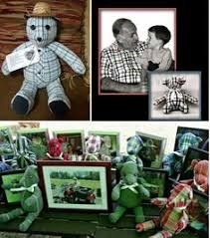
A fun and healing workshop for children and adults, grieving the death of a loved one. Families will work together to create a keepsake bear in memory of their loved one. This workshop is open to the community at large, and is free of charge. Lunch will be provided.

Saturday, February 15, 2020
10:00-2:00

The Wellness Center 650 Highland Ave
Winston-Salem, NC 27101

Special thanks to
Cardinal Innovations.

Instructions for fabric: Choose a piece of clothing that reminds you of your loved one. An adult size button down shirt works best with the pattern provided. If your item requires a smaller pattern, please let us know upon registration.
Please bring any special items, like pins or ribbons, that you would like to incorporate into your bear for decoration.
Please note: The fabric will be cut and re-sewn and permanently altered to make the bear. In some cases, there will not be any leftover fabric.

Space is limited. To register, please call Kristie Byrd at 336.789.2922 or
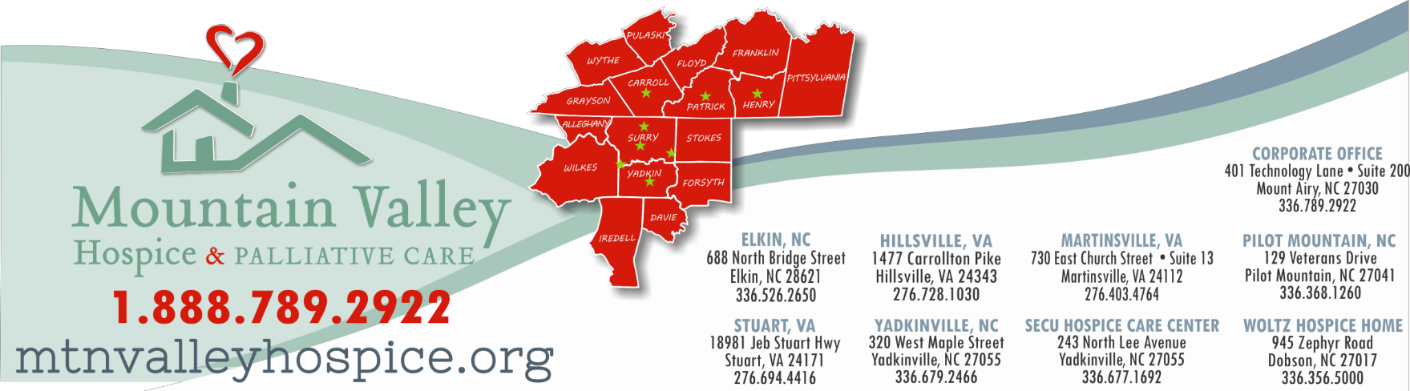
email kbyrd@mtnvalleyhospice.org.

